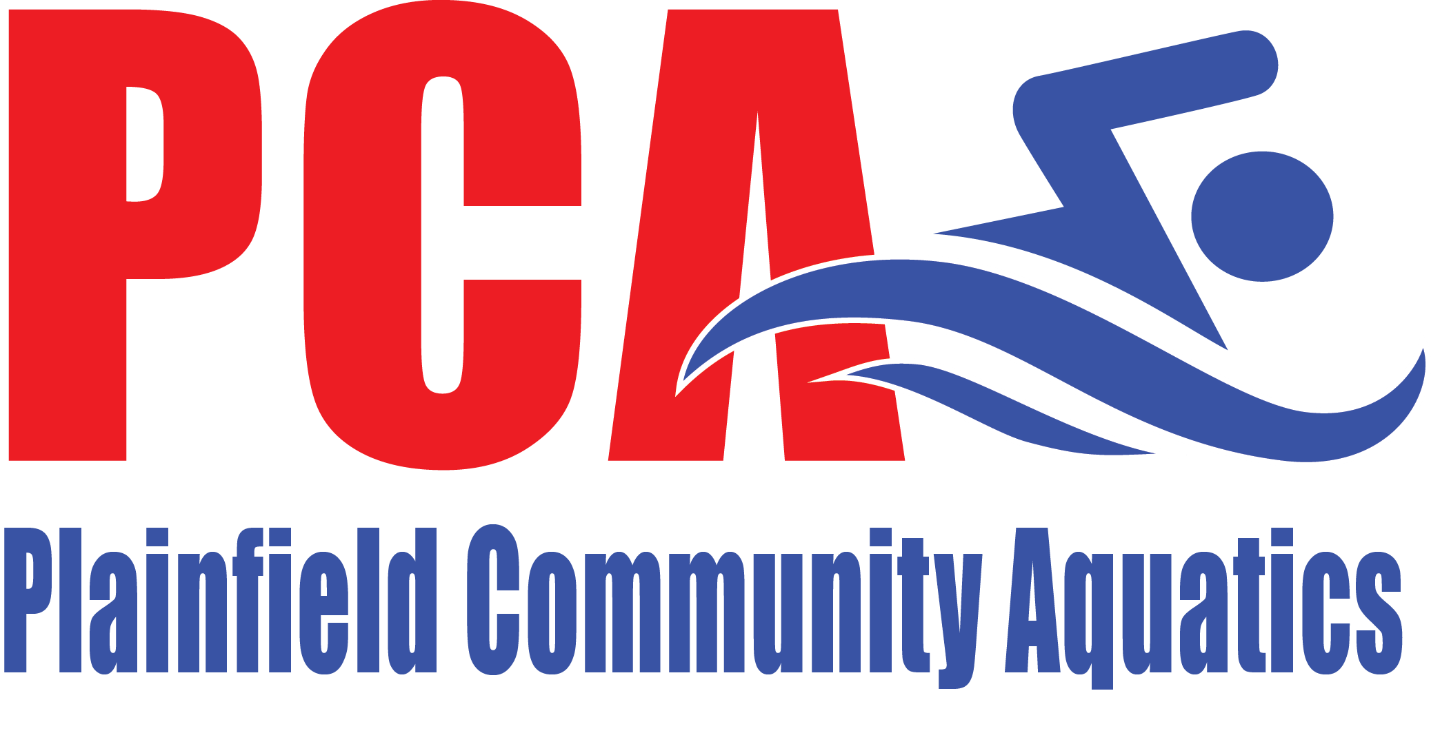

2025-2026 PCA Annual Acknowledgement
Welcome to Plainfield Community Aquatics for the 2025-2026 Short-Course season! This document provides you with specific details related to the upcoming season. Please review this document and the PCA Handbook carefully. The PCA Handbook can be viewed under the Forms/Policies tab once you have logged into the PCA website.
- Team support requirements I agree to provide team support as detailed in the Team Handbook. PCA will host our annual PCA Invitational swim meet November 7-9, 2025. Hosting a swim meet is an excellent fundraising opportunity for PCA, and we will need the help of every PCA family to host a successful meet. Instead of requiring families to donate Hospitality/Concessions food & supplies for the meet, each family will be charged a $50 Registration Fee. Every PCA Club family will also be required to volunteer at the meet, so please save the date on your calendar. Work sessions are mandatory. There will be a $150 fine PER REQUIRED SESSION for not fulfilling the volunteer requirement. More details will be communicated when volunteer needs are determined.
- Financial obligations I agree to pay the attached 2025-2026 Short-Course fees and adhere to the financial and membership considerations described in this document and in the Team Handbook.
- Team Handbook I hereby acknowledge that I have reviewed, understood, and agree to comply with and be bound by all of the terms, conditions, obligations, and policies detailed in the Team Handbook as if fully set forth herein.
General Consent I hereby give consent for my child(ren) to participate with Plainfield Community Aquatics. In consideration of being permitted to participate as a member of the Plainfield Community Aquatics swim team, I hereby release, discharge, and agree to hold harmless Plainfield Community Aquatics and its coaches, members of the Board of Directors, its volunteers, its agents, and its employees, together with its successors and assigns, from any and all liability for injuries to property or person suffered as a result of participation as a member of Plainfield Community Aquatics. I also understand that the club can use my contact information for corporate purposes and communication. I understand that PCA may contact me directly. PCA does not sell its membership list to third party services.
By electronically signing during registration, I acknowledge this consent is binding on behalf of my child(ren) and each parent/guardian of said child(ren), and I have reviewed the contents referenced herein with said children.

Parent/Guardian________________________________
Dated ____________________
2025-2026 PCA SHORT-COURSE FEE SCHEDULE
Monthly fees:
- Senior: $375 for the entire season collected in 3 payments of $125 (September + October & November invoices)
- Juniors: $125/month
- Breakers: $105/month
- Swells: $85/month
- Ripples: $75/month
Multi-Swimmer Discount for families with 2 or more registered PCA swimmers (applies to Monthly Club Fees / Lesson Session Fees only):
- 1st Swimmer (at highest fee) - full price
- 2nd Swimmer (at 2nd highest fee) - 10% discount
- 3rd Swimmer (at 3rd highest fee) - 20% discount
- 4th+ Swimmer(s) - 30% discount
Registration Fee: $50/family (note: the Registration Fee will increase to $150/family on 11/1/25 for the remainder of the season)
USA Swimming Membership Fees: USA Swimming Membership Fees are NOT being charged as part of this registration. USA Swimming membership is required for PCA Club team members. If your swimmer is new to USA Swimming, they have a 30-day grace period from their PCA start date to register with USA Swimming. Returning Club swimmers must have a 2025 USA Swimming membership before they attend PCA practice.
USA Swimming 2026 membership options will be:
- 2026 Premium membership ($88.75) – effective 9/1/25-12/31/26.
Please use this link to register your swimmer for USA Swimming Membership: https://omr.usaswimming.org/omr/welcome/B1FF4EEAB8074F & email pcaswimregistrar@gmail.com if you have any questions.
Meet Fees: You are responsible for paying the meet fees for all competitions your child enters once the meet registration deadline has passed. Once your child is entered in a meet, PCA pays for all of its entries and your child’s meet fees will be charged to your PCA account. If you do not “un-commit” your swimmer through PCA’s swimpca.org website by the stated deadline for the meet, you will be responsible for the meet fees even if your child is unable to compete due to illness or other circumstances. Meet fees vary depending on the meet and the number of events your child swims, and meet fees generally range from $25-$50 per meet. Meet fees will be automatically charged to your monthly invoice, and no credit will be issued if your child is unable to compete due to illness or other circumstances.

Payment methods:
You will be required to place a credit card on file for autopayment of your monthly invoice when registering your child for PCA’s Club team. A credit card processing fee of ~3% will be charged for all credit card transactions & this processing fee is paid directly to the credit card processor. After registration, you will have the option to set up Autopayment by ACH Debit from your bank account. A processing fee of $1.25 will be charged for all ACH Debit transactions, which is also paid directly to the credit card processor. Checks will no longer be accepted.
If your payment transaction is rejected, you will have until the 21st of the month to make an On-Demand credit card payment of your balance due to avoid a $10 late fee. All credit card, bank and system fees incurred from rejected payments are the responsibility of the account holder.

Free and Reduced Lunch Discounts (Outreach):
Families who qualify for the free and reduced lunch program through their school system will receive a 50% discount in monthly Club fees only. You must provide documentation annually to the PCA Treasurer when you register your child. Discounts will not be applied retroactively and no additional discounts (e.g., multi-swimmer discount) will apply. USA Swimming offers a discounted Outreach membership fee to families who qualify.

Suspension or Termination of Membership:
When you register your child for PCA’s Club team, you are committing to pay the monthly fees for the entire season (Short-Course Season: August - March).

Account suspensions are for medical purposes only and must be for no less than a 4-week timeframe. Athletes will not be able to participate in practices or meets during this account suspension. Written request must be submitted by emailing the PCA Treasurer at swimpcatreasurer@gmail.com and must be approved by the PCA board. A doctor's note is required.

Swimmers new to PCA’s Club Team can terminate their membership in their first season by emailing the PCA Treasurer at swimpcatreasurer@gmail.com at least 10 days prior to the 1st of the next billing month.
Any other requests to suspend or terminate your swimmer’s membership with PCA will be evaluated on an individual basis by PCA’s Board of Directors. You must email the PCA Treasurer at swimpcatreasurer@gmail.com at least 10 days prior to the 1st of the next billing month.

Swimmers will be charged for the full month fee if they attend any practices or meets within that month. Once fees have been paid, no refunds will be issued.
Any outstanding meet fees are considered an obligation to PCA and are payable upon suspension or termination of membership. Please also be aware that in the event that a meet deadline has passed for a future meet in which the swimmer has committed to swim, these fees will also be due at the time of termination if the club is unable to scratch the swimmer.

Team Suit:
All swimmers attending swim meets must wear a PCA Arena suit & PCA swim cap. Please use this link to order the PCA Arena suit: https://elsmoreswim.com/collections/plainfield-community-aquatics. Arena suits are available to purchase through this Elsmore website at any time. Name-personalized PCA swim caps will be available to purchase at the beginning of each season from this Elsmore website. Non-personalized PCA swim caps are available to purchase at the pool from coaches for $13/cap; you can pay cash or your account will be charged. An Online PCA Spirit Store will be available to purchase additional (optional) PCA clothing at the beginning of each season & information will be sent out to families at that time.

Required Swim Gear:
Ripples/Swells/Breakers: Goggles, Kick board, Pull Buoy, Fins, Mesh Bag
Juniors/Seniors: Goggles, Kick board, Pull Buoy, Fins, Hand Paddles, Mesh Bag
Senior Group coach recommended (not required): Tempo Trainer & Snorkel

I recognize my responsibility to abide by the rules, code of conduct and requirements of the Plainfield Community Aquatics Club Team. I acknowledge that I have reviewed the contents of this document and payment of the registration fees acknowledges agreement to this statement.
Parent/Guardian________________________________
Dated ____________________

